|  |
| --- |
| 新东方在线英语学习 |
| 新概念 1 册 |
| Lesson53-54 |



扫一扫。更多有趣的英语资讯。

# Lesson 53 单词讲解

1. mild: 温和的，温暖的mai ao d

It is mild in fall. 秋天天气很温和。

mild food 清淡的食物

spicy food 辛辣的食物s bai c

1. always: 总是，一直，永远

Wai si te

S ai ou si

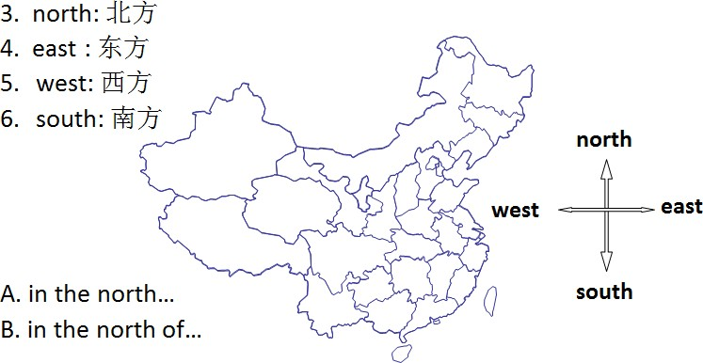



1. news: 消息、新闻
2. East, west ,home is best.

金窝银窝，不如自己的草窝。

1. wet: 潮湿的(wai te)
2. Wu yi pu

water- wash- wine(wai n)- wave(wei f)- well- weep-woman…

1. season: 季节c zen
2. 一年有四季。

There are four seasons in a year.

They are spring, summer, fall\ autumn and winter.

1. best: 最 adv、最好的 adj. Green is my favorite color.

I like green best. （行前动后）

Beijing is my favorite city.

. Spring is his favorite season.

. Chinese is her favorite langue.

.

1. night: 夜晚、深夜

evening: 傍晚

1. rise: 升起rua ai zi
2. set: 落下

太阳每天上午 6 点升起，7 点落下。

The sun rises at 6:00 in the morning and sets at 7:00 in the evening.

1. early: 早的 adj.\ adv.
2. late: 晚的 adj.\adv.

I am late today. adj.

I come today. adv.

1. interesting: 有趣的
2. subject: 话题、科目

What’s the subject we are going to talk about today? We have nine subjects this term.

1. conversation: 谈话
2. an interesting climate

# Lesson 53 课文讲解

1. What’s the climate\weather like in…+ (月份、季节、地点)?
2. 描述天气的句型结构:

It is…in…

春天天气很糟糕。It is terrible in spring.

西边气候很干燥。It is dry in the west.

厦门天气很宜人。It is pleasant in Xiamen.

1. Which seasons do you like best? Which is your favorite season? Which are your favorite seasons?
2. 昼短夜长:

The nights are short and days are long.

昼长夜短:

The nights are long and the days are short.

Si ai ao dom 偶尔 很少

# Lesson 53 语法讲解

Usually 一直 u 这lei

2. 频率副词的位置:

情、系后，实义前

She is seldom ill.

He can never sleep.

He always loves her.

他老是迟到。

He is always late.

他经常给女孩写情书。

He often writes love letters to girls.

表达强调时，可调整位置。我永远也记不住。

I can never remember. I never can remember.

# Lesson 54 单词句型讲解

1. Australia- Australian: 澳大利亚，澳大利亚人ao si chui lia ao si chui lian
2. Austria- Austrian: 奥地利，奥地利人ao si chui ya ao si chui n
3. Canada-Canadian: 加拿大，加拿大人can na da can ni di en
4. China- Chinese: 中国，中国人
5. Finland- Finn ish: 芬兰，芬兰人fen lan de
6. India-Indian: 印度，印度人in di ya in di en
7. Japan-Japanese: 日本，日本人
8. Nigeria- Nigerian: 尼日利亚，尼日利亚人nai zhe rui ya
9. Turkey- Turkish: 土耳其，土耳其人te er key te er ki shi
10. Korea- Korean: 韩国，韩国人
11. Poland-Polish: 波兰，波兰人pao lan d paoleishi
12. Thai- Thailand: 泰国，泰国人tai tai lan d

# Lesson 53&54 知识拓展

谈谈天气常见天气

* 1. 晴朗: sunny\ clear
  2. 阵雨: rain showers shai ao zi
  3. 小雪: light snow
  4. 冰冻: freeze
  5. 大部多云: mostly cloudy
  6. 局部有风: partly windy
  7. 飓风: hurricane ha rui ken
  8. 雾霾: haze hei z
  9. 暴雨洪灾: rain and flood

1. 抱怨天气:

The weather is bad\ terrible.

I’m feeling a bit under the weather.

1. 喜欢某种天气:

I like…\ I love…

I am crazy about…

